## NKHBES001

**EEE4120F Prac 1**

### Introduction

### This report investigates the performance difference between optimized and non-optimized functions, analysing their speed. Additionally, it examines the correlation between shifted sine waves.

### Methods

#### Part 3 step 4

In step 4 of part 3, generate noise using a for loop. Fill an array with random numbers, then normalize it to have an amplitude of 1:

Figure 1: custom white noise generator.

#### Part 4

To implement the Pearson product moment correlation coefficient, was done by finding the mean of each data set, then the covariance of each data set, and then the standard deviation of each data set, divided the covariance by the product of the two standard deviations:

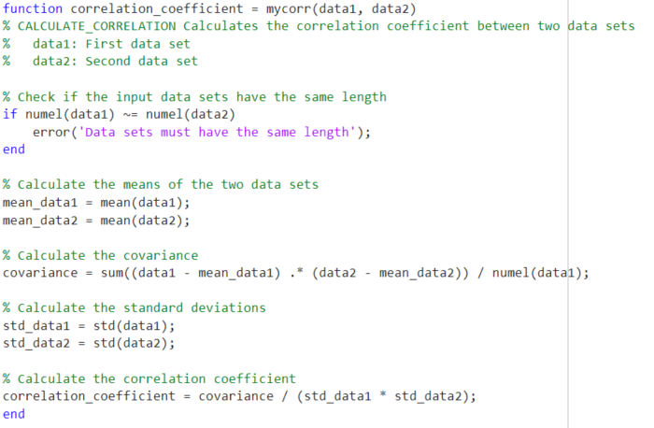

Figure 2: custom Pearson product implementation

A quick validation of my method produces these differences from the inbuilt correlation calculator:

Figure 3: differences between build in function and mine

The differences round out to 0, so my method is fairly accurate.

##### Part 4 step 3

A sinusoid was instatiated with an amplitude of 1 and a frequency of 1/10 and varied the sampling rate and the amount of time a sinusoid is shifted by.

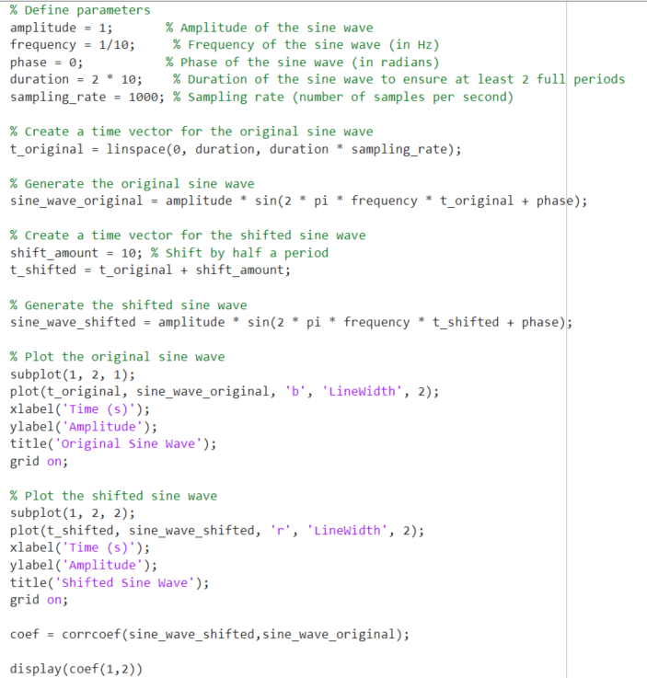

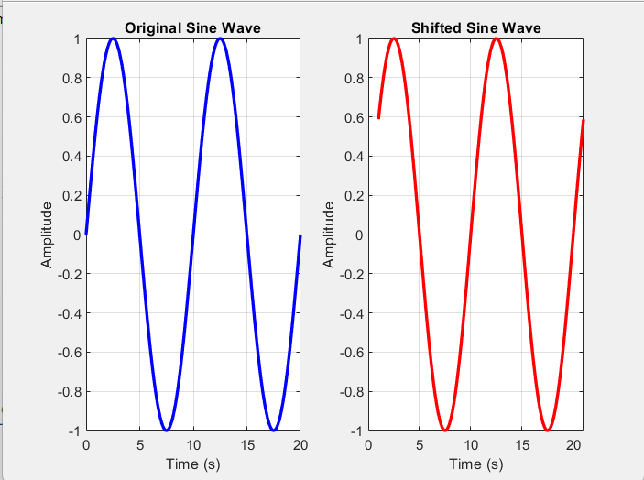

Figure 4: Examples of functions compared.

It is expected that the correlation coefficient will be sinusoidal, where in when the shift increases the correlation coefficient should decrease to a point, and then start increasing again when the wave goes back in phase, with the period set to 10 seconds, it should be expected that the correlation coefficient should go back to 1 when then sine is shifted by 10 seconds.

### Results & Discussion

#### Part 3 step 4

|  |  |  |  |
| --- | --- | --- | --- |
| **Duration of the clip** | **Using a for loop** | **Built in method** | **Speed up** |
| 10 | 0.018382 | 0.01052 | 1.748 |
| 100 | 0.158877 | 0.04842 | 3.28123 |
| 1000 | 1.693087 | 0.51195 | 3.30713 |
| 10000 | 17.10276 | 5.2884 | 3.23402 |
| 15000 | 27.1384553 | 8.33977 | 3.2541 |

By varying the duration of each clip generated, it can be noted that using a for loop is generally slower than using the built in method, it is about 3 times slower for larger loads.

#### Part 4

|  |  |  |  |
| --- | --- | --- | --- |
| **Sample size** | **My Corr speed(ms)** | **Corr speed(ms)** | **speed up** |
| 100 | 1.625 | 1.076 | 0.662154 |
| 1000 | 0.606 | 0.307 | 0.506601 |
| 10000 | 0.695 | 0.316 | 0.454676 |

The built in correlation function is faster than then custom made one by a factor of about 2.

##### Part 4 step 3

|  |  |  |
| --- | --- | --- |
| **Number of samples** | **Amount of time shifted(s)** | **Correlation co-efficient** |
| 100 | 1 | 0.8089 |
| 2 | 0.3089 |
| 5 | -1 |
| 7 | -0.3089 |
| 10 | 1 |
| 1000 | 1 | 0.8089 |
| 2 | 0.3089 |
| 5 | -1 |
| 7 | -0.3089 |
| 10 | 1 |
| 10000 | 1 | 0.8089 |
| 2 | 0.3089 |
| 5 | -1 |
| 7 | -0.3089 |
| 10 | 1 |

As expected, the correlation coefficient is itself be sinusoidal, where in when the time shift increases the correlation coefficient should decrease to a point, and then start increasing again when the wave goes back in phase.

### Conclusion

In conclusion, it was found that the inbuilt methods tend to scale better than un optimized versions of the code.

It was found that shifting a sinusoid has the effect of creating a sinusoidal correlation with its original.